1. **Tell me about yourself:**

Thank you very much for inviting me to be interviewed for this position today morning. I have 10 year experience in Id industry, and i am a professional software developer with several skills and qualities that i believe will be benefit to your organization.

If i talk about my current assignment, so I am working in TCS now and currently i am engaged with the Europe one of the best bank project in Nordic reason, Nordea Bank. Here we have several portfolios where we working as team. I am working on two important areas 1- Credit Risk Capability and 2- Global Fraud Monitoring

If we talk about my current roles and responsibility so I am working as lead developer, and since This is scaled agile based project so apart from development work i have some other responsibility like participating in PI Ceremony, feature discussion, user sotry creation, estimate them and assigning to the team member.

If i talk about technology stack which i am using in my current project are, java 8 and spring boot for Microservice development, DB2 & MySQL as backend DB, Power Curve as a rule engine , Kafka for messaging, Weblogic and Tomcat for running and deployment of the application, Bit-bucket code repository and Jenkins CI-CD pipeline for deployment.

Apart from this, in my past projects i have worked web application development using JSR 168/286 portlet technology using IBM Web Sphere Application and Portal Server as backend and html, jsp, JavaScript, JQuery from the frontend side.

And finally I would like to say that I am very strong team worker and i strongly believe in team work with the individual work.

I am also very good at building up relationship with clients and customers and i feel this will benefit to your organization from commercial prospective.

So yeah, this is pretty much about me. Please let me if you want to know more about the current project on which i am working now.

**1- Can we overload main ()**

Ans: Yes we can overload main method.

**2- How do we invoke the overloaded main method? And how does the java understand which main it has to call?**

Ans: As we know that when we declare a method with same name but different parameters then it is called method overloading and when we call the particular overloaded method with its defined parameter then if JVM finds the method name and its type of parameter is matched then JVM invokes that particular overloaded method, same thing will happen in case of main ()

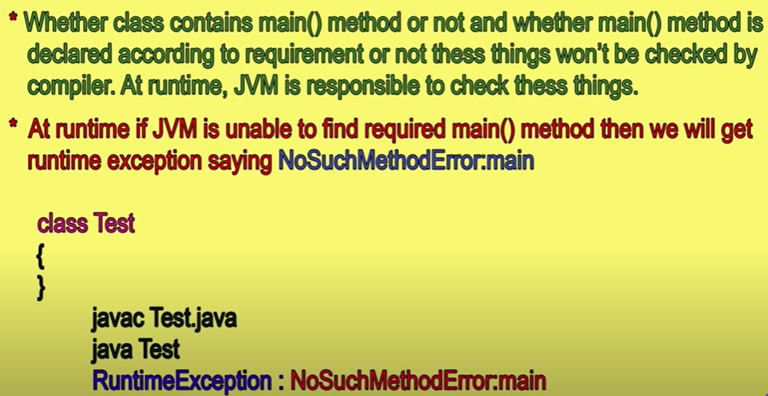

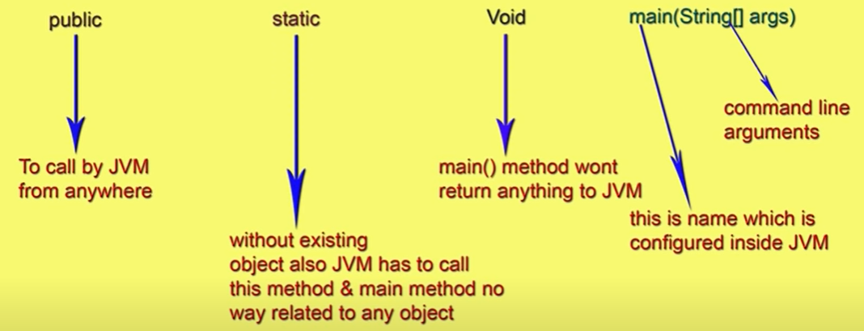



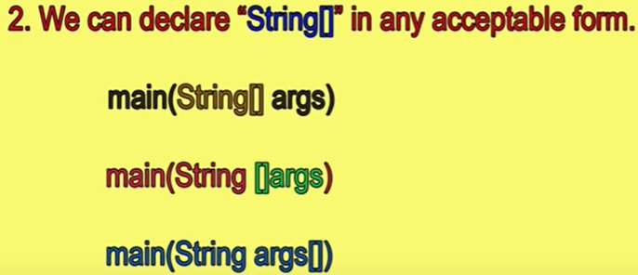





public static final synchronized void main(String[] arguments) { }

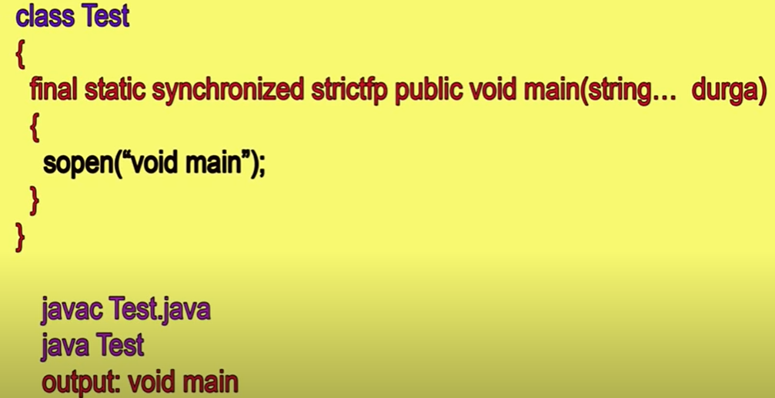

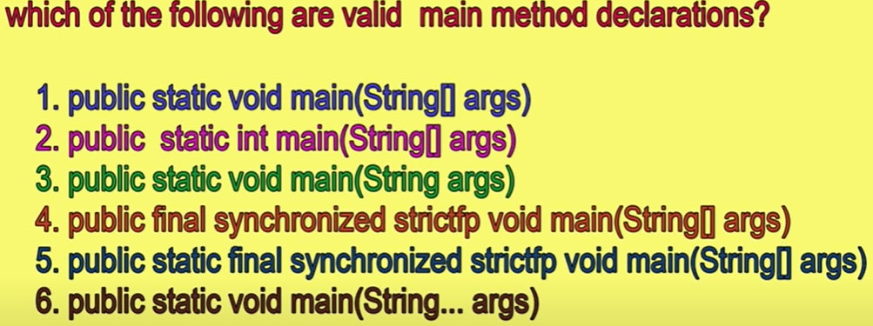



3- What happens if i call a main method within another main method?

Ans: In this case it will be considered as normal instance method or static method.

4- Is Null an Object in java?

Ans: We can consider null is an object with empty string

5- What auto-boxing and un-boxing in java?

6- Do you thing System.gc() always prevent java from out of memory?

7- What is the difference between pass by value and pass by reference.

8- Let's say we have try-catch-finally block and we don't want to execute finally block, then how do we manage the code

**System.exit(0)** by convention, a zero status code indicates successful termination.

**System.exit(1)** -It means termination unsuccessful due to some exception

**System.exit(-1)** -It means termination unsuccessful due to some exception

9- How do the certificates work in java when you expose services on SSL

10-Define the structure of JWT

11-What is mutual authentication in java and how do you implement in your project?

12-What is spring cloud

13-In Spring boot how do you configure the log level and how do you change the log level to debug.

14-Git Pull and fetch difference

15- How Many ways we can create an object of the class. Four ways to create object

1. Using new() operator

Employee EMP = new Employee ();

1. Using Factory method

Employee account = Employee.getEmployee(“Accout”);

1. Using newInstance() i.e. using java reflection. Here it takes two steps in creating object
2. First Store the class name (Employee) as a string into an Object and for this purpose, factory method forName() of the class ‘Class’ will be used

Class c = Class.forName(“Employee”); [ Here Class is nothing but class found in java.lang package]

1. Next, create another object to the class whose name is in the object [c] and for this purpose we will use newInstance() method of class ‘Class’

Employee obj = (Employee) c.newInstance();

1. By cloning an already available object

Employee obj1 = new Employee();

Employee obj2 = (Employee)obj1.clone();

16. How many method available in the Object class? Ans – 9 methods

1- equals() , 2- toString(), 3- getClass(), 4- hashCode(), 5- notify(), 6- notifyAll(), 7- wait(), 8- clone(), 9- finalize()

-------------------------------------------------------------------------------------------

17- **When we should go for abstract class?**

If we are taking about implementation but not completely (partially implementation) then we should go for abstract class.

For example: Let’s we have one car class so in the in every class there should be some common feature like , Registration number , FuelTank() , sterring(), Engine(). Now Registration number and fuelTank() will be common to all the car, for we will provide the implementation in the Car (which is an abstract Class) itself and for the specific feature like steering, every car has their own feature of steering, like telescope, power steering , manual steering , so we will create this method as abstract method in the abstract class Car and we will create one sub class for implementation of steering feature according to type of car. Similarly every car has their own specific engine so we cannot implement as common feature in the Car class, and that is why we will declare it as abstract method and we will provide the implementation this abstract method its sub class according to the type of car.

Another example.

In the back we have different type of account and every account will have some common feature and will have some specific feature, for example saving account will have their own rate of interest and current account will have their own rate of interest, but the calculation formula of total amount based on rate of interest would be same so, we will create one abstract class bank where will create one abstract method rateOfInterest() which will have their own implementation based on account type and we will have calculation implementation in the Back abstract class as a common feature.

**18- When we should go for Interface**

As we know that in an interfaces we just declare the methods and every methods are abstract by default, and we have to implement these methods into their sub class and one more thing is that we have to implement all the methods declare in the interface, so when we want to implement a complete new functionality or if we want to re-implement the existing functionality completely then we should go for interface. For example let’s say in our application we are using oracle database and to use the data base we are using connect () and disconnect () method. Later let’s say we want to use another database like MySQL then in this case instead of using

19- What is static import in java?

1- What are the best practices that you are working or designing microservices?

2- what is kibana and grafana?

3- In Microservices which authentication and authorization is using? Or how did you configure authentication and authorization in Microservices?

4- What is JWT Token and how does it work? When this token goes to the server then what kind of the check is applied on that token? Can we put validation on the IP address like whome they are getting it?

5- What are the different method in the Rest API? POST, GET, PUT, PATCH, and DELETE

6- What is the PATCH method in REST API?

7- What kind of data we can pass in the request? How max information we can pass through query param?

8- What is abstraction and where we can use abstraction? \

9- Real world scenario whare we can us abstraction and can use abstract class and interface.

10-Is there any other way to achieve abstraction apart from using abstract class and interface: Ans : Using factory classes is also abstraction: Data hiding is also a type abstraction eg: declaring data as private is a type of abtraction.

11-Let's consider we have one hashmap haveing key-value pair where key have from 1- 10 number and in value i have string value

12-What the put method returns?

13-What is the exception Heirarchy .

14-Throwble is interface or class

15-What all the methods available in Object class

16- Can we define Object class method in the Functional Interface: A: No , we can just declare but can not define method inside Functional Interface.

17-Design pattern - Singleton class ? How we can create singleton class in multithreaded environment? Double checking loking? using the volatile variable we can create the singleton class

What is volatile and atomic

-------------------------------------------------------------------------------------------

1- Can we override the private or static method in java

2- Difference between hashmap and hashtable

3- Singleton class in java and how we can create a singleton class in java. Can we make singleton class thread safe?

4- Expression 1.0 /0 will returns what?

5- Does two object alwyas be equal when there is their two compare method retuns zero

6- What is immutable class and how to create custome immutablee class?

7- If the String is aaa or bbb or ccc then output would be a3 b3 and c3 so what will be approach to solve this.

8- How will you implement your hashmap in java? Or Hashmap internally works?

9- What is executer service (Multithreading)?

10- What is thread deadlock?

11- How to prevent dead lock?

12- If a method throw run time exception in super class then can we override it with the method which thrown runtime exception.

13- Can we change the size of array once created?

14- What is stream API Or what are the new feature introduced in java 8 ===> What is streams

15- What is flat map?

16- In Streams API can you write any program? Basically we have an array and this array contain 1 to 10 number and i want to filter those numbers which are less than five.

17- What is Concurrent HashMap? How it is different from Normal HashMap?

18- How many object will be created for the below statment in the memory? - String temp = "A"; String temp = "B"; String temp = "C";

19- Can we have finally without catch blokc?

20- Difference between Spring MVC and Spring boot?

21- Difference between Controller & ResController

22- Dispatcher Servlet?

23- Spring Boot actuator?

24- How do you create your own custome annotation?

25- When to use @Autowired and @Qualifier

26- Why to @ControllerAdvice is used?

27- Difference between Monolitihic and Microservices Architecture.

-------------------------------------------------------------------------------

1- How many topic you have created?

2- How you are authoring and authonticating your project. Basically Spring Security--- JWT Token is being asked

3- Are you using any encrption and description in JWT

4- How much amount are you covering in Mocito Jnuit.

5- Are you using Sonar also? Where you are maining your code base?

6- Where are you developing your functionality in the branch?

7- Do you have any idea about CI-CD

8- How you are maintianing docer file. What is the main advantage of Docker.

9- How you are testing your microservices (Postman or swagger)?

10-What is sand box?

11-What is the sprint duration? After every sprint are you showing demo or how?

12-Which Design pattern are you using in your current project ( API Gateway is Design Pattern ? )

13- Syso(1+3+"Arun")

14- What all things are you using from Java-8

15- What is the main advantage of Functional Interface?

-------------------------------------------------------------------------------------------

What is the advantage and disadvantage of Microservices

How would you identify the status of microservice?

How would you communicate with the microservice?

Which naming server you are using- Eureka

How to deploy your application in the tomcat server.

How to start multiple thread or how to initilize the multiple thread.

What is dead lock and in what condition the dead lock comes?

What is Deomaon Dread and can we start or stop the deomen thread?

Write a query to get max salary from the table having empid and salary?

What is the difference between == and === in javaScript

When we can go for Interface and Abstract class.

Question JPA & Hibernate.

Can we override private method method?

Do you know about caching? How do you implement caching in your project